Malahide Credit Union – Gaining Online Access to your account
First you need to register for online access. Click the REGISTER NOW button on our website https://malahidecu.ie/
This is will take you through the registration process.
After you have registered for on-line access and you have received your PIN in the post you are ready to access your account on our website or App.
Member log in process – via website
STEP 1: ENTER YOUR USERNAME (YOU WILL HAVE SET THIS UP AT THE REGISTRATION PROCESS)
STEP 2: THEN ENTER YOUR PIN (RECEIVED IN THE POST, THIS IS EIGHT DIGITS)
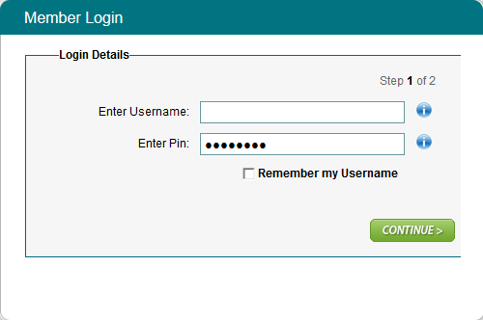
STEP 3: ENTER YOUR PASSWORD (THIS IS A MINIMUM OF 8 DIGITS)
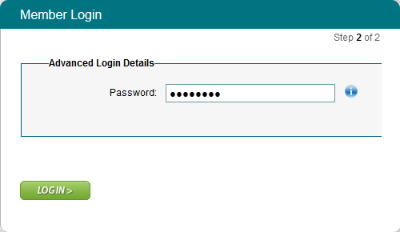
Then Click on the LOGIN button and you will see MESSAGE TO MEMBERS, click CONTINUE
The first time you log on, the next screen will ask you to ACCEPT or DECLINE our terms and conditions.
If you click accept you will then have access to your account and the options to the left of the screen.
A funds Transfer option can be given as an extra on the Accounts listing. To get this option you must come into the Credit union with Proof of address (dated within 3 months) and photo id as you need to sign terms and conditions.
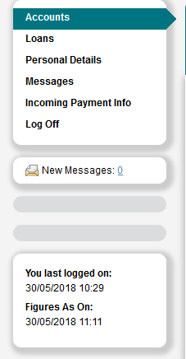

Member log in process – via APP
Logging in VIA the android APP (on phones and tablets) is the same as above but may look a little different as it may ask you for different digits from your pin (e.g. 2nd digit, 4th digit, 6th digit).

